**Disaggregated APIs for SONiC Hosts (DASH)**

**Executive Summary**

DASH, known as Disaggregated APIs for SONiC Hosts, is a fresh open-source project created by the SONiC community. It makes use of advanced DPU technologies. DASH includes a bunch of APIs (an extension of SAI) and models for objects, which handle network services for the cloud. With DASH, any application a business uses can work much faster. This new technology follows the SDN approach to set up the data plane, speed up the flow processing.

UANDWE is ready to help DPU vendors in DASH prototyping/Demo’s.

**Introduction**

**Background**

SONiC, developed by the Open Compute Project (OCP), provides a platform-agnostic, open-source network operating system that runs on various hardware platforms. The success of SONiC has driven the industry towards disaggregated networking, decoupling hardware and software components to promote interoperability and innovation.

**The Need for DASH**

DASH optimize cloud services performances by using the programmable hardware for flexible high speed flow processing at scale.

Introduces a reference model known as the "Behaviour Model" to articulate the use case requirements for technology providers. It is expected that technology providers, including DPU and SmartNIC vendors, adhere to these use case requirements to qualify their devices for deployment in Data Centres. DASH follows a top-down approach.

**Key Objectives**

The DASH overall objective is to optimize network Programmable Technologies performance and handle peak hour needs, and leverage commodity hardware technology to achieve 10x or even 100x stateful connection performance with hardware offload and leveraging parallel processing for specific tasks.

**Architecture of DASH**

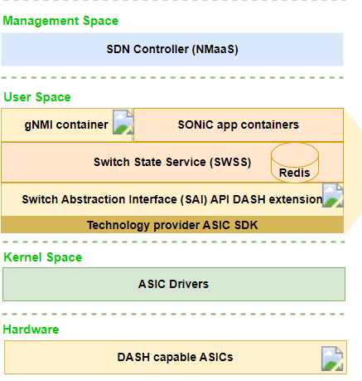

Source: Above picture is sourced from DASH community.

**Use Cases**

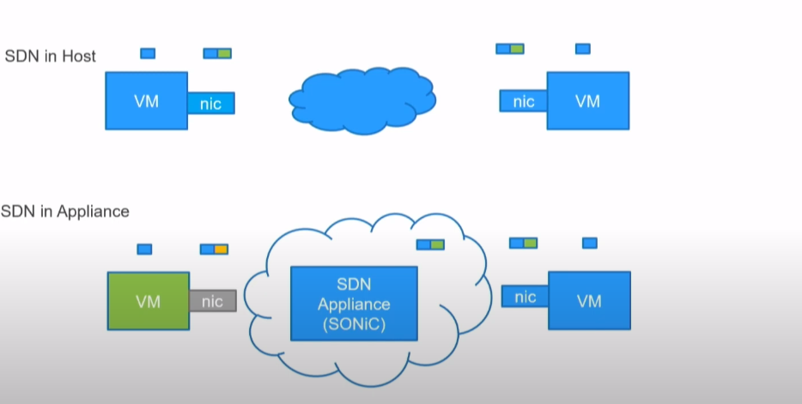

Source: Above picture is sourced from DASH community Youtube.

SDN in Host – All intelligence is built into Host(ESIx) NIC. VM NIC does a complex encap(Routing,LPM,ACLs) and decap.

SDN in Appliance – VM nic is configured with Appliance IP address. VM nic does simple encap to forward the packet to Appliance. Appliance does the magic of building complex encap.

What is the benefit of moving SDN from Host to Appliance?

Appliance is dedicated hardware(DPUs) pool available for VM to offload the routing and rules. So, Connections per seconds, Packets per seconds improves greatly

**SONiC-DASH Development Partner**

To deliver a DASH-based prototype, DPU vendor needed to work with a reliable software partner capable of enabling its DPU solution for DASH. A startup industry, UANDWE is focused on Disaggregated or Open networking. Months of experience with SAI and SONiC, community involvement and in-depth knowledge of various ASIC SDKs and NOS.

UANDWE is ready to help DPU Vendors in implementing of DASH library (SAI API extension), PoC, Demos.

Top of Form